# Labjournal

## 

### 2018-03-21

What did we do

* Built a set-up (figure 1): using a pre-3D printed scaffold for droplet positioning, home-made LED set-up contained in an eppendorf box for diffusion. To this we added a breadboard and shock absorbers to minimize oscillations of the droplet while measuring as this will affect the result.
* We tried to control a syringe pump by computer. This failed, as the communication via the I/O port was not in line with the provided software communication protocol. We decided to put the problem on hold.
* We tried to use opendrop, the software in Python from the paper by Tabor. We were unable to run this, due to errors probably caused by a lack of installed modules. We decided to move on to use Matlab as it has a built-in image processing toolbox. We found the function Hough transform in Matlab that looked promising for identifying the edges of the droplet in the image.



Figure 1 Set up of the drop tensiometer

What are we going to do

* LK is going to improve the setup by building a holder for the smartphone so the camera is stable while filming, and by increasing the stability of the light source.
* ZP and SvD are going to focus on the Matlab code required to analyse the picture.
  + The first focus will be to write a script to locate the droplet
  + The second focus was to rotate the picture so that fitting will go more easily
  + After this we will think about how we are going to perform the fit

### 2018-03-22

What did we do

* We wrote Matlab code to locate the droplet on the picture called LocateDroplet. This was done by converting the edges of the droplet to lines, and the converting these lines to points. Thereafter we divided the image into boxes of different size. The points in each box were fitted to a circle with a diameter of half the box size. For this we used the equation x2+y2=R2. The box were this fit led to the least error was picked as the location of the droplet. This did not give us the droplet location as the droplet was not a perfect circle. Some boxes turned up with only 1 centred point in it because we did not divide the error by the number of points in the box. All changes in the code can be found on drension/src/history/20180322.
* We designed instrument including smartphone holder and lightsource stabilization to be 3D printed. The design can be found in drension/3d-printing/Pendant_drop_meter.123dx. During the designing the light source broke.

What are we going to do

* LK will print the design of the instrument with a laser 3D printer
* LK will think about way to implement a syringe pump in the set up to accurately control volume growth of the droplet
* SvD and ZP will solve the problems in the code to accurately find the droplet on the image

### 2018-03-23

What did we do

* Light source has been fixed.
* We wanted to print the design with the 3D printer. Unfortunately the printer was already printing something else. Therefore the design will be printed at the end of this day and we can continue our work after the weekend.
* We tried to initiate communication between the computer and the syringe pump. It seems that the computer software available for the syringe pump is too old to be supported on the computer. The syringe pump started pumping when the software was started, but could not be controlled further by the software, not even to be switched off. We decided to control the syringe pump manually.
* We solved the MatLab problems in LocateDroplet. For this we changed the requirements thus that all points should have an equal distance to the centre of the box and that the mean of all points added together was equal to the centre of the box. The error was divided by the number of points in the box. The box with the lowest error indeed contained the droplet. Furthermore, we cropped the image based on the box size in which the droplet was found. All changes in the code can be found on drension/src/history/20180323.

What are we going to do

* SvD and ZP are going to write code to rotate the image so that the needle is parallel to the force of gravity, to improve the fit of the young-laplace equation.
* LK will build the tensiometry set up after the design is printed.

## Week 2

### 2018-03-28

What did we do

* The design was 3D printed by fablab. Unfortunately the first two attempts at printing went wrong. At the first attempt the 3D printer seemed to have dropped the object before it was dried and therefore it was completely malformed. At the second attempt we ran out of printing material before the object was finished. The third attempt was done with another 3D printer and yielded the correct design. We polished the slid for the light diffuser to remove excess material and improved the fit of the light diffuser. We added Styrofoam to the phone holder to protect the smartphone from scratches and improve the fit. There was no polishing needed for the needle holder as it had a diameter that was a little too large for the needle. Therefore, we increased the diameter of the needle with tape to improve the fit. We then build the set up on a breadboard with shock absorbers and added the syringe pump to control droplet volume. The complete set up is shown in figure 2. With this set up we made test pictures (see figure 3) and a movie of a growing droplet. the movie can be found in drension/movies/20180328_162442_water_calibration_2.mp4.
* We made a function called ‘MakeDroplet’ that simulates the shape of a droplet based on the bond number. For this we used the coupled set of differential equations obtained when the Young-Laplace equation is expressed in terms of the cylindrical coordinates *r* and *z* used in Berry et al. We also devised a plan to rotate the image to make the needle parallel to the y axis of the image. This should make fitting of the Young-Laplace theory easier. To determine the sin of the angle by which the image should be rotated we want to divide the width of the needle by the distance between the intercepts of the edges of the needle with the top of the picture. All changes in the code can be found on drension/src/history/20180328.



Figure 2 New set up.

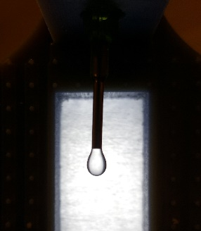

Figure 3 Test picture of a water droplet made with the new set up. Original picture can be found in drension/photos/20180328_pendant_water_droplet_small.jpg

What are we going to do

* SvD and ZP will rotate image based on needle intercept and fit picture with the simulated droplet based on Young-Laplace equation.
* LK will make test videos of water droplets that are oscillating

### 2018-03-29

What did we do

* Made video of oscillating droplet using a syringe pump. This video can be found at drension/movies/20180329_133019_water_calibration_1.mp4.
* We finished the MatLab code to find the angle (θ) by which the image should be rotated and called it NeedleAnalysis. To do this we first located the intercepts of the needle edges and called these b1 and b2. Then we divided the y-axis of the image into segments and located the edges of the image in these segments. For the edge in each segment we calculated the angle with b1 and b2 by taking the arctangens of the gradient. These angles were expected to be bigger when the droplet was reached. Therefore, if both the angle with b1 and the angle with b2 exceeded a certain critical angle the values were omitted to make sure we only measured the angle between the needle and the top of the picture. Then we used the angles of the needle points with b1 and b2 to determine θ. We calculated the needle width by multiplying the distance between b1 and b2 with the cosine of θ. The changes for this code can be found in drension/src/history/Needle Analysis Function Finished.
* We made a MatLab code to find the lowest point of the droplet and centre the picture around x0 and y0 called Find_lowest_point. We set x0 at (b1+b2)/2 , which corresponds to the middle most x value of the needle. Then we set y0 at the minimal y value found for x0. We then plotted the picture with the new x and y values. The changes for this code can be found in drension/src/history/we found x0 and y0 and centered the image
* Other minor changes in the code can be found in drension/src/history under commits for Mar 29, 2018

What are we going to do

* SvD and ZP will fit the simulated droplet based on bond number to the rotated and centred picture of the measured droplet.
* LK will measure suitable liquids with the new set up.

## Week 3

### 20180404

What did we do?

* We have decided to no longer use the code that localizes the droplet in a complex image (LocateDroplet), as this requires a lot of effort and time to do properly and, as the set-up remains the same among different experiments, manual cropping is more effective and more precise. This code can be found in drension/src/history/20180404
* We wrote a function (FindDropletEdges) that finds the edges of a cropped droplet. This is important to scale the droplet to a width of 2 and translate the vertex of the droplet to (0,0). This function relies on screening the droplet image space in segments and then selecting the segments that contain the outermost points of the droplet, thus finding the edges.
* The function that simulates a droplet for a Bond number (MakeDroplet) is now resized as to correspond with the resizing of the droplet points. This is required for proper fitting. This code can be found in drension/src/history/20180404
* We wrote a fitter (YLFitter) that fits a set of experimental points to the Young-Laplace equation for a range (Bmin to Bmax with steps of a certain accuracy) of Bond numbers. This fitting is done by minimalizing the least distances of the experimental points to the Y-L equation simulation. The error is normalized for the number of experimental points to allow for comparison amongst different droplets. This code can be found in drension/src/history/finished fitter.
* Iterative fitting was added to the main code, as to allow zooming on the region of best Bond numbers a few times to find a more accurate result for the Bond number. This can be found in drension/src/history/20180404
* We added minor other improvements to and fixed minor mistakes in the code. These changes can be found in drension/src/history/small changes.

What are we going to do?

* SvD and ZP will improve the FindDropletEdges function to make it more precise. It appears as if the edges are really fitted on the outskirts of the data points, instead of in the middle. This might give a bias in fitting.
* Svd and ZP will calculate the droplet volume (V) from the Y-L equation, calculate surface tension and Worthington number from the obtained Bond number and radius.

Other ideas

* Measure surface tension of gelatin droplet while solidifying and try to relate surface tension to temperature
* Find the effect of a surfactant on surface tension of an oscillating droplet

### 20180405

What did we do

* We made a list of interesting fluids to measure, and measured a number of those (water, ethylene glycol and ethanol).We made movies of the dispensing of these solvents. The movies were analysed with the software. From the obtained data we could conclude that, as suggested by Berry et al., the surface tension approaches the values reported in literature when Wo (Vdrop/Vmax) approaches 1 (see Figure 4). These videos can be found in drension/movies with the file names 20180405_161119_ethyleneGlycol_calibration.mp4 and 20180405_163229_ethanol_calibration.mp4. The water we measured was tap water, ethylene glycol with CAS number of 107-21-1 came from EMSURE, ethanol 96% vol with CAS-number of 64-17-5 from VWR chemicals.
* We had difficulties measuring the surface tension of ethanol (especially as function of time), as ethanol had a strong tendency to stick to the needle and form a droplet around the needle, instead of hanging from the needle (see Figure 5).
* We edited the code of the programme as to enable the analysis of videos. The analysis code was called for each frame in a certain time range.
* We were able to convert from pixels to meters using the thickness of the needle as a conversion factor.
* Code was added to calculate the volume of a droplet in the MakeDroplet function, using the integral for revolution of a 2D space around the Z-axis.
* Wo and Gamma were calculated from the obtained Bond number in the code.
* All changes in the code can be found in drension/src/history/20180405

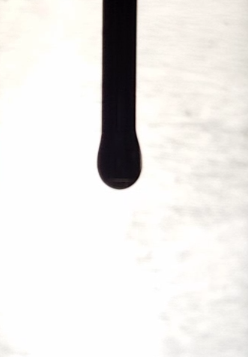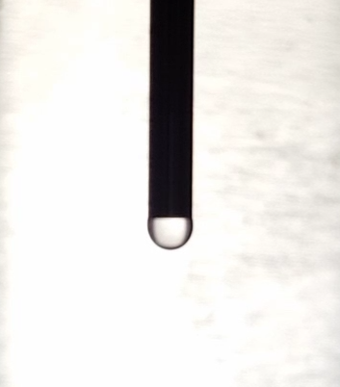

Figure 4 Droplet of ethanol during the dispension. A) Small droplet hanging from the needle. B) Bigger droplet, adhered to the needle (needle indicated with red lines).

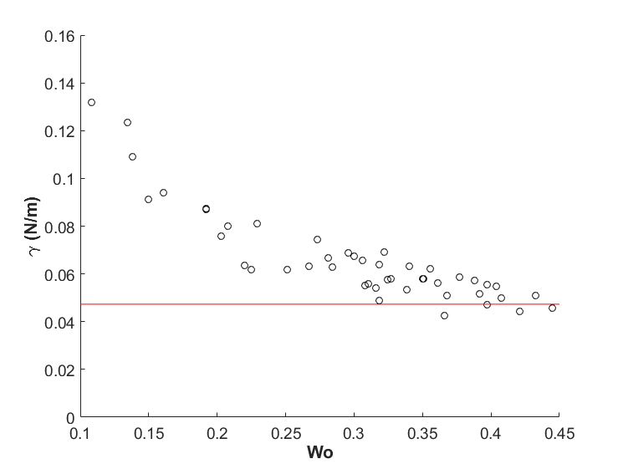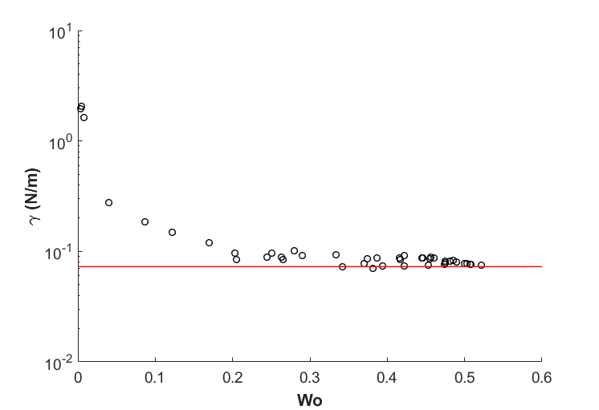

Figure 5 Surface tension plotted as function of the Worthington number (Vdrop/Vmax) for an ethylene glycol droplet (a) and a water droplet (b). The reported literature surface tensions are indicated by the red line.

**A**

**B**

What are we going to do

* + LK will measure droplet containing pectin and lysozyme at different lysozyme concentrations to find optimal lag time for change in surface tension
  + LK will measure surface tension using a wilhelmy plate
  + SvD and ZP will find correct parameters by making droplet videos with higher resolution and use less slices in the fitting process

Other ideas

* + Measure surface tension of gelatin droplet while solidifying and try to relate surface tension to temperature
  + Find the effect of a surfactant on surface tension of an oscillating droplet
  + Use magnetic nanoparticles and a magnet to alter surface tension
  + Coat the needle with CF2 end groups exploiting aluminium oxide surface chemistry as to enable the measuring of low surface tension liquids such as ethanol.

### 20180406

What did we do

* The surface tension of water, ethylene glycol and ethanol was determined using the Wilhelmy plate method. FILE NAME AND LOCATION
* A short protocol for the Wilhelmy plate method:
  1. Clean all glassware and rinse it with the solvent to be used.
  2. Measure the width of the plate and straighten the Wilhelmy plate.
  3. Rinse the Wilhelmy plate with ultra-pure water. After rinsing, dry and clean the plate by heating it, untill it is red-hot, with a butane-torch (only use torches that produce a blue flame, as other torches will leave carbon contamination on the plate).
  4. Hang the plate underneath the balance using tweezers (to avoid contamination), make sure the plate does not swing and tare the balance.
  5. Put the beaker on the platform under the plate and move the platform so the plate just touches the liquid.
  6. Wet the complete plate by slightly lifting the beaker with liquid.
  7. Wait untill the wait is stable.
  8. Calculate the surface tension by γ = 9.81 * M/2L, with γ the surface tension in mN/m, M the mass in g, and L the width in M.
  9. Repeat step 3 to 9 for the duplo/triplo measurement.
* Finished full analysis of videos of water, ethylene glycol and ethanol with the code. These resulted in graphs that gave insight in the fluctuations of our parameters. This seemed to correspond well with the Wo number as predicted in literature. We made figures from the results of this analysis which can be found in drension/calibration.
* The final fitting process was visualized in a cartoon. This cartoon is shown below (figure 5).

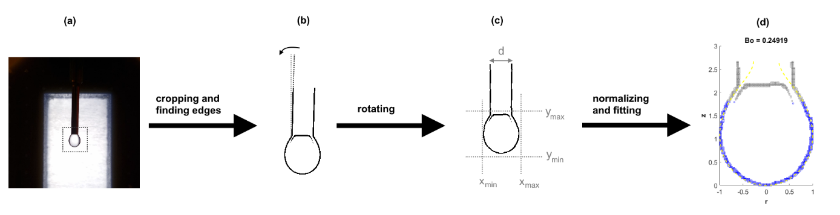

Figure 6 Cartoon of the fitting process. (a) An image of a droplet is cropped to a pre-defined space and (b) rotated based on the needle. (c) The image is analysed to find the edges of the droplet, which are used to (d) transform and fit the droplet to the Young-Laplace equation. Original pictures can be found in drension/process-cartoon

## Week 4

### 20180411

What did we do

* We measured surface tension of a 0.1 gram/litre ovalbumin solution with the wilhemy plate method for 30 minutes to see when surface tension (γ ) stabilizes. For this we used albumin purified from chicken egg white with purity ≥ 98% from Sigma-Aldrich, with a CAS number of 9006-59-1. We fit these data in excel with

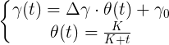

where θ is the adsorption on the surface and Δϒ is the ultimate difference in surface tension caused by complete adsorption of the protein to the surface (see figure7, cf. Langmuir). The excel file can be found in drension/excel/ 20180411_Wilhelmi_plate_Protein.xlsx

* Searched for literature about protein adsorption kinetics in relation to surface tension to explain the fit we found with the Wilhelmy plate analysis.
* Measure surface tension of water over longer time periods with the set up in a box with a cup of water to minimize droplet evaporation. Droplet evaporation still occurred, therefore we assumed that the air was not yet saturated enough and decided to use cups with hot water. We also used a time-lapse app instead of the normal video function to get a smaller file that is easier to store. This video is locally stored on SvD’s account on the … drive as the file was too large to be uploaded on GitHub.

Figure 7 Surface tension of a 0.1 gram/litre ovalbumin solution over time. The result was fitted with the equation presented

What are we going to do

* Determine whether protein adsorption kinetics are similar to surfactant adsorption kinetics and which equations are of importance
* Analyse the found literature

### 20180412

What did we do

* From the literature we came to the following theory about the relation between surface tension and the adsorption of proteins (ovalbumin in our case) to the air/water interface: We propose that the apparent (measured) surface tension can be described as the weighted average of 2 surface tensions, the surface tension of air/water and of air/protein (Similar idea to the Cassie-Baxter relation for the contact angle on heterogeneous surfaces). As the absorbed amount of protein changes over time, we expect the surface tension to shift from the surface tension of water/air, to the surface tension of protein/air. However, due to interactions between molecules, it is difficult to predict/calculate the surface coverage of the protein. To make matters even more difficult, we did not yet consider the denaturation of proteins on the surface (and the influence on the protein/air surface tension). The adsorption of proteins on surfaces is a long studied subject, as papers can be found as early as 1939 (Langmuir et al.) However, during most studies, assumptions were made which do (most likely) not hold for drop tensiometry. In most studies, it is assumed that the surface is a perfect sink and all proteins stick to the surface (with infinitely large Ka) and never come loose (infinitesimally small Kd). However, during drop tensiometry the available surface area is limited and the adsorption of a protein will hinder the adsorption of the next (non-infinite Ka). Also, in other studies, linear (1d) diffusion is assumed, as the proteins will diffuse from the bulk solution to the surface (top of the beaker) due to the concentration gradient caused by the adsorption of proteins to the surface. However, during drop tensiometry, we have to take into account the 3D-radial diffusion. This means that most (if not all) equations based on linear diffusion cannot be used for this system. We want to find equations that still reasonably predict protein kinetics in drop tensiometry. The literature can be found in drension/literature
* We wanted to test the effect of protein adsorption on the light scattering. Therefore we put a small drop of water with 0.1 gram/litre ovalbumin on a cover glass and illuminated this with a laser. Unfortunately, the light scatter pattern seemed to result solely from the constitution of the cover glass instead of the droplet, and did not change over time. Therefore we could not conclude anything based on this experiment.
* We tried to analyse the pendant drop time-lapse made the day before. Unfortunately, the parameters did not correspond with what we expected. After closer examination of the fitting process this seemed to be caused by the fact that the droplet of the video was not centred correctly. These deviations ware barely visible by the eye, but led to large deviations in bond number, droplet volumes, and surface tensions. Because the code worked well for the other videos, we thought this might be caused by the difference in image resolution which could lead to a deviations in the droplet edges found by FindDropletEdges.

What are we going to do

* SvD is going to resolve the problems that occur during fitting of the time-lapse images.
* LK is going to take time lapses of droplets of different ovalbumin concentration.
* ZP and LK are going to improve the labjournal (add pictures, add graphs, add data from the paper labjournal).

### 20180413

What did we do

* SvD extended the FindDropletEdges algorhytm to fix the problem of non reproducable fits. For this we divided the points of the droplet edges into a right curvature, a left curvature and a bottom curvature. For each curvature we took the average x value for which the dx/dy value was smallest. This removed the previous error. All changes can be found in drension/src/history/fixes non reproducible fits by extending the edge algorithm
* LK and ZP inserted data from the paper labjournal into github and the electronic labjournal.

What are we going to do

* LK is going to take time lapses of droplets of different ovalbumin concentration.
* ZP will measure different ovalbumin concentration with the wilhelmy plate method
* SvD is going to setup multiple computers to process the time-lapses produced by LK

## Week 5

### 20180418

What did we do

* We made a 10 g/L ovalbumin solution. To 0.09654 g ovalbumin was added 9.778 gram demineralised water, yielding an exact concentration of 9.89 g/L.
* Timelapses of the droplets were made with the following setup (unless stated otherwise):

Pictures of the droplet over time were taken, using the previously described setup, using a Samsung Galaxy S6 Edge + as camera. The free app Framelapse was used to take a picture each second (to reduce the amount of data by a factor 30). The resolution was 1920x1080. The solution was suspended using a 2 mL glass pipet with inner diameter X. This diameter was also entered into the syringe pump, to dispense the right volume of solution. The dispensed volume was 30 µL.

* Lars measured the surface tension over time of a droplet of 0.1 g/L ovalbumin solution. The ovalbumin solution made on 2018-04-12 was used  
  INSERT FILE NAME AND LOCATION
* Lars measured the surface tension over time of a droplet of 10 g/L ovalbumin solution. The freshly prepared 10 g/L ovalbumin solution was used.

INSERT FILE NAME AND LOCATION  
Note: The surface tension is expected to decrease. This means that the maximum droplet size is expected to decrease. So creating a very large droplet (close to the maximum of the setup) will result in the droplet falling off shortly after starting the measurement.

* The surface tension experiment of a 10 g/L ovalbumin solution droplet was repeated with a droplet volume of 25 µL.
* The 10 g/L solution was diluted 10 times and the surface tension was again measured over time.
* SvD setup multiple computers to process the time-lapses produced by LK, as one analysis takes 3-10 hours depending on the amount of computer cores. Now the analysis can run overnight. (see figure …)

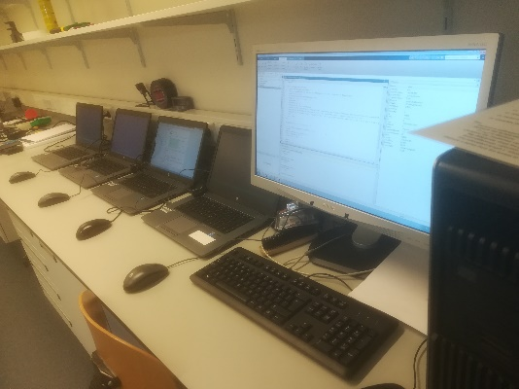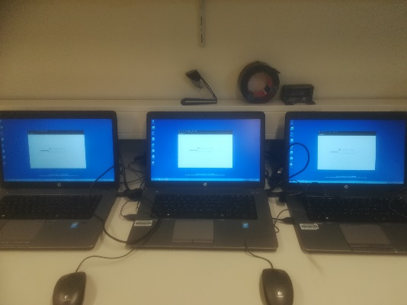

Figure 8 Computer setup to analyse time lapses

What are we going to do

* LK is going to measure more time-lapses of different ovalbumin concentrations
* SvD is going to analyse the data produced by the processing of the images.
* SvD is going to adapt the matlab script to better display the trend of the surface tension (for instance moving average).
* ZP going to provide a more in depth description of the Wilhelmy plate analysis (what apparatus used, what chemicals/solvents used)
* ZP is going to start on the poster.

### 20180419

What did we do

* The computers are done with analysing the videos. Some errors occured. The computer that analysed the 0.1 g/l albumin droplet did not analyse the last few frames, this was not a problem as there was still enough data and the surface tension was relatively constant (see figure..). We decided we would not measure albumin concentrations below 0.1 g/l, as there is not much too see within the time range that we measure. The computer that analysed the 1 g/l albumin droplet did not yield comprehensible results (see …..). The analysis of the 10g/l albumin droplet went well until 550 seconds, thereafter the bond number was 0.078 and the surface tension >2 N/m. We thought this might be caused by a too small droplet size.
* LK repeated the drop tensiometry measurement for the 1 g/l albumin concentration. He also measured concentration of 2.5 g/l. (see…)
* LK and ZP measured the 10 and 2.5 g/l albumin concentrations with the wilhelmi plate method. As the surface tension for this concentration stabilized after about 10 minutes with drop tensiometry (see figure…), the wilhelmi experiment was performed for 15 minutes. The results of the wilhelmi plate measurement can be found in drension/excel with the titles 20180419_Wilhelmi_plate_10gl_Albumin and 20180419_ResultsFitting-2.5gL.
* SvD fitted the results from drop tensiometry and the wilhelmi plate method with

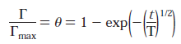

For both methods the same T-value was found (see drension/excel/20180419_ResultsFitting-10gL).

* SvD also fixed the error named in point 1. To prevent too low bond numbers a minimum bond number value of … was set. It turned out that the droplet size was not the cause of the error. The error occurred when finding the bottomPoints in FindDropletEdges. Due to the error the droplet was fitted to a simulated droplet that started at a too high point, even though the image was still centred well. It turned out that dividing the zMax-bottom by 3 instead of 2 fixed this problem. Why? The BMin, BMax and BAccurcy were altered to prevent local minima and reduce the computational duration. This also improved the results. All changes in code can be found in drension/src/history/script edits.

What are we going to do

* SvD will analyse the fitting results of matlab of the 1 and 2.5 g/l albumin videos
* LK and ZP will start with the poster

### 20180420

What did we do

* LK measured the 2.5 g/L ovalbumin concentration again as the droplet fell down in the previous measurement.
* SvD analysed the MatLab Data and fitted this to the above mentioned formula. The results can be found in drension/excel/20180420_Collected_Results_Ovalbumin
* SvD, LK and ZP worked on the poster. The poster can be found in drension/poster/20180420_Poster
* The computer is still analysing the 2.5 g/L ovalbumin solution

What are we going to do

* Finish the poster